Extract from the article.
Accent coaches hear a lot of funny stories. A personal favourite came from a Spanish nurse: "One of my patients, she ask me about her fadder, 'is he getting washed?' I say yes of course, every day, and she look very upset. I realise, she did no say 'washed', she say dis word …" She wrote down the word "worse".
The longer I teach pronunciation, the more often I find myself listening to a different kind of story. The nurse whose patients ask to speak to someone else, the consultant whose promotion is postponed until she sounds "more English", even though she's no more difficult to understand than Marion Cotillard. In an economy where we so frequently encounter people who aren't as comfortable communicating in English, how many are we subconsciously judging.
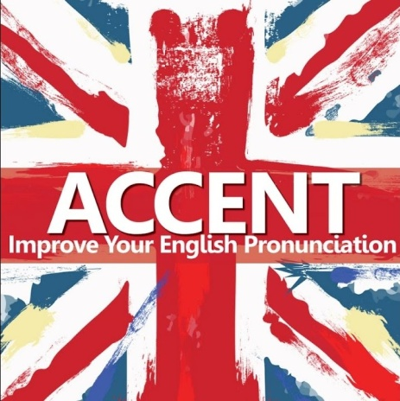
I tripped and stumbled into accent coaching. I'd returned to London from a two-year stint in Mexico where I became bilingual and skint. I was saving for an expensive journalism master's, starting with whatever the bureau de change would give me for my crumpled pesos.
A study by the University of Chicago found a sentence said in a foreign accent is less likely to be believed. Why? If the sentence was: "Oh, Farage and me, the laughs we've had", I'd understand the scepticism. Otherwise it seems bizarre. Apparently, it comes from an "inability to separate what's being said from how it's being said". But that doesn't answer the question of why an unfamiliar formation of sounds undermines credibility. The tips of their tongues touching their teeth when they say "t", or saying "doze" instead of "those" seems a flimsy basis for mistrust. So, do we think foreigners are dishonest or stupid?
Even out-and-out xenophobes start sentences with, "I don't mind foreigners, but …" While it's tedious to hear bigotry tarted up as a point of view, at least the lie is an acknowledgement that xenophobia isn't acceptable. But companies don't start sentences with, "we're not xenophobic, but …" – they make it company policy. Sergey sounds Russian and it makes clients uncomfortable; let's hire someone to make him sound English. Never mind that the client's discomfort is far less reasonable than a Russian having a Russian accent.
I'd love to sit in on one of their budget meetings. "I'm afraid we can't buy new printers, that money's gone into removing all evidence that Marco, Xi and Abdul were born outside the home counties."
It's not just us. The study found the same reaction to foreign accents in all countries – arguably solving the mystery of why so many Hollywood baddies are English. But we monolingual Brits have less right to pass judgment. We have the worst language skills in Europe. Many of us can't even properly pronounce the food we eat (bruschetta is "bru-SKET-a". We should stop saying "bru-shet-a" if we don't want to drive Italians crazy).

